Spark Performance Tuning Tips

Use DataFrames instead of RDDs:
Instead of using the RDD API
rdd = sc.textFile("/path/to/file.txt")
Use the DataFrames API
df = spark.read.textFile("/path/to/file.txt")
By using the DataFrame API and not reverting to using RDDs you enable Spark to use the Catalyst Optimizer to improve the execution plan of your Spark Job.

Utilize Broadcast Join for joining Smaller Datasets to Larger Ones:
In many cases, we will be joining smaller data sets with larger data sets. In this case, it’s more performant to use a Broadcast Join:
joinedDF = largeDF.join(broadcast(smallDF), largeDF("id") === smallDF("some_id"))

Put the Largest Dataset on the Left:
When you’re joining together two datasets where one is smaller than the other, put the larger dataset on the “Left”:
joinedDF = largerDF.leftJoin(smallerDF, largerDF("id") === smallerDF("some_id"))
When Spark shuffles data for the join, it keeps the data you specified on the left static on the executors and transfers the data you designed on the right between the executors. If the data that’s on the right, that’s being transferred, is larger, then the serialization and transfer of the data will take longer.

Use Caching:
If you find you are constantly using the same DataFrame on multiple queries, it’s recommended to implement Caching or Persistence:
df.cache()
Note: Avoid overusing this. Due to Spark’s caching strategy (in-memory then swap to disk) the cache can end up in slightly slower storage. Also, using that storage space for caching purposes means that it’s not available for processing. In the end, caching might cost more than simply reading the DataFrame.
Partition on Well-Distributed Columns:
A powerful way to control Spark shuffles is to partition your data intelligently. Partitioning on the right column (or set of columns) helps to balance the amount of data that has to be mapped across the cluster network in order to perform actions. Partitioning on a unique ID is generally a good strategy, but don’t partition on sparsely filled columns or columns that over-represent particular values.
Partitioning/Parallelism:
- It is recommended to have 2-3 tasks per CPU core in your cluster.
- Even though Spark attempts to infer a sensible number of partitions for your collections, sometimes you may need to tune the level of parallelism by optimizing the number of partitions.
- HDFS input RDDs are typically partitioned based on the number of HDFS blocks the data resides on.
- RDDs that are derived from other collections simply inherit the number of partitions from the parent collection.
- Minimize the number of shuffles by using partitioning mechanisms that would allow the program to know that a set of keys will appear together on the same node.
  - Hash partitioning: the keys that have the same hash value will appear on the same node.
  - Range partitioning: the keys within same range appear on the same node.
- Spark operations that involves shuffling data by key benefit from partitioning: cogroup(), groupWith(), join(), groupByKey(), combineByKey(), reduceByKey(), and lookup()).
- repartition and coalesce: Repartitioning (repartition()) is an expensive task because it moves the data around, but you can use coalesce() instead only of you are decreasing the number of partitions.
- To repartition the data and to have your records sorted in each partition, use repartitionAndSortWithinPartitions() instead of calling repartition and then sorting within each partition because it can push the sorting down into the shuffle machinery.
Avoid using your own custom UDFs:
What actually happens behind the screens, is that the Catalyst can’t process and optimize UDFs at all, and it threats them as blackbox, which result in losing many optimisations like: Predicate pushdown , Constant folding and many others.
Try to avoid UDFs as much as possible and instead use Spark SQL function — make sure to find the ones that are relevant to your Spark version.
Avoiding UDFs is not always possible, not all functionality exists in Apache Spark functions. But, try using built-in Spark SQL functions, as with it we cut down our testing effort as everything is performed on Spark’s side. These functions are designed by Databricks experts.
When there is no built-in replacement, it is still possible to implement and extend Catalyst’s (Spark’s SQL optimizer) expression class. It will play well with code generation.
Set the spark.sql.shuffle.partitions parameter:
Shuffle is the transportation of data between workers across a Spark cluster's network. It's central for operations where a reorganization of data is required, referred to as wide dependencies.
This kind of operation can quickly become the bottleneck of your Spark application. To use Spark well, you need to know what you shuffle, and for this it's essential that you know your data.
The default value for this is 200 which can be too high for some jobs. Set this configuration to the number of cores you have available across all your executors.
spark.conf.set("spark.sql.shuffle.partitions", 10)
COMPUTE STATISTICS of Tables Before Processing:
Before querying a series of tables, it can be helpful to tell spark to compute the Statistics of those tables so that the Catalyst Optimizer can come up with a better plan on how to process the tables.
spark.sql("ANALYZE TABLE dbName.tableName COMPUTE STATISTICS")
In some cases, Spark doesn’t get everything it needs from just the above broad COMPUTE STATISTICS call. It also helps to tell Spark to check specific columns so the Catalyst Optimizer can better check those columns. It’s recommended to COMPUTE STATISTICS for any columns that are involved in filtering and joining.
spark.sql("ANALYZE TABLE dbName.tableName COMPUTE STATISTICS FOR COLUMNS joinColumn, filterColumn")
Memory Management:
- Execution memory is used for computation (e.g., shuffles, joins, sorts, and agg).
- Storage memory is used for caching and propagating internal data.
- Jobs that do not use cache can use all space for execution, and avoid disk spills.
- Applications that use caching, reserve minimum storage space where the data cannot be evicted by execution requirements.
- Set spark.memory.fraction to determine what fraction of the JVM heap space is used for Spark execution/storage memory. The default is 60%.
- Avoid using executors with too much memory as it would delay the JVM garbage collection process.
- Avoid using a lot of very small executors to be able to still benefit from running multiple tasks in a single JVM.
Use narrow transformations instead of the wide ones as much as possible:
In narrow transformations (e.g., map()and filter()), the data required to be processed resides on one partition, whereas in wide transformation (e.g, groupByKey(), reduceByKey(), and join()), the data to be processed resides on multiple partitions and so needs to be shuffled.

Use reduceByKey() instead of groupByKey():
Avoid using groupByKey() for associative reductive operations. Instead of that, use reduceByKey().
With the reduceByKey(), Spark combines output with common keys on each partition before shuffling the data.

Skew Causes Bad Shuffles:
Skew is an imbalance in the distribution of your data. If you fail to account for how your data is distributed, you may find that Spark naively places an overwhelming majority of rows on one executor, and a fraction on all the rest.
This is called skew, and it will kill your application, whether by causing out of memory errors, network timeouts, or exponentially long running processes that will never terminate.
Deal with null values while joining dataframes:
Joins are by far the biggest shuffle offender, and the dangers of sql joining are amplified by the scale Spark enables. Even joining medium sized data can cause an explosion if there are repeated join values on both sides of your join.
If there is a chance your join columns have null values, you are in danger of massive skew. A great solution to this problem is to "salt" your nulls. This essentially means pre-filling arbitrary values (like uuids) into empty cells prior to running a join.
Use Parquet format:
Parquet file format is designed to offer read/and write operations an order of magnitude more efficient than uncompressed plain files.
Parquet is "columnar" in that it is designed to only select data from those columns specified in, say, a Spark sql query, and skip over those that are not requested.
Furthermore, it implements "predicate pushdown" operations on sql-like filtering operations that efficiently run queries on only relevant subsets of the values in a given column.
Switching from uncompressed tabular file formats to parquet is one of the most fundamental things you can do to improve Spark performance.

Understand the execution plan:
From Dataset object or Dataframe object you can call the explain method like this:
dataframe.explain(true)

The output of this function is the Spark’s execution plan which is the output of Spark query engine — the catalyst. Here you can check yourself and see if there are ‘redundant’ calculation.

In order to reduce the number of stages and shuffling, best practice is first to understand the stages and then search for a way to reduce the complexity.

This is an example of calling explain method of a query with UDF:
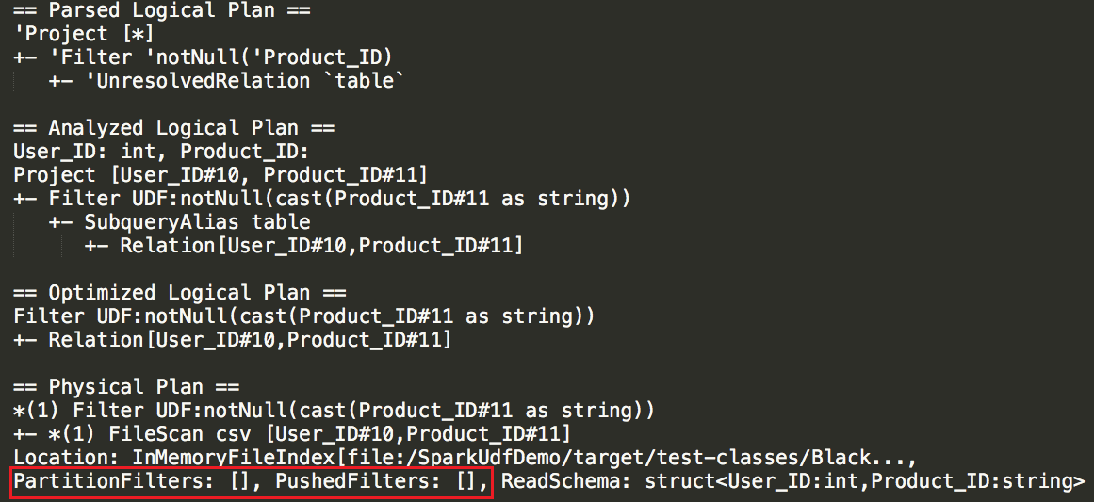

Physical plan shows what will actually happen in our executors, we can see the partition filters, pushdown filters, the schema, the project method. In this example, getting all the data from a CSV file without filtering any records.

So, modified the query to use in-built function instead of using UDF. From the output, we can see that we are using the power of Pushdown filter (last line in the physical plan).

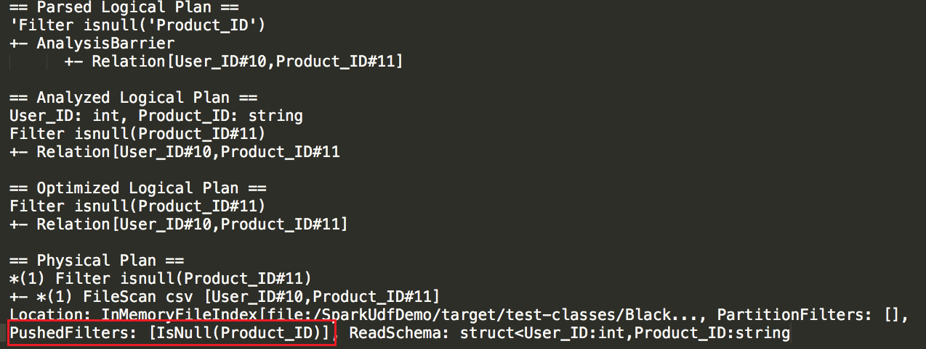

Without UDF, we might benefit from the pushdown filter which will happen at the storage level that means that it won’t load all the data into Spark memory because the Spark process reads the data after the storage already filtered what’s needed to be filtered.

